|  |  |  |
| --- | --- | --- |
|  | Name | Date |
| Created by | Sarita Borikar | 06/20/2017 |
| Reviewed by |  |  |
| Version Number | Ver 1 |  |

**MnP 878880015_ Cmpnt 00049010 cannot be outed , Cmpnt ct is less than Zero**

# Issue

## Description:

EFMS received GTE for Receive GIOM Billing Reply.

Error message - 8|78880015| Cmpnt 00049010 cannot be outed , Cmpnt ct is less than Zero

# Order Detail

Order Number- 171893647

# Sample USH –

000000268976135

000000268707710

000000268705126

# Trouble Shoot:

Open the order in BVOIP tool.

Check the status on order. You can see the order has failed with billing error.



Error Message- 8|78880015| Cmpnt 00049010 cannot be outed , Cmpnt ct is less than Zero

## UNIX Logs:

N/A

## Database:

N/A

# Interfacing Applications:

EFMS, CADM

# Workaround Provided:

**Step 1**- Check the billing log for the order.

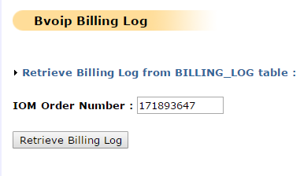

**Step 2**- Check the component value being sent to CADM for the component – 00049010 in the billing logs.

[0](String)ACTIVITY_TYPE  
[1](String)CMPNT_PATH  
[2](String)CMPNT_ID  
[3](String)CMPNT_CT  
[4](String)CMPNT_TYPE_CD  
[5](String)CUST_SPECIFIED_RATE_CODE  
[6](String)ACCT_LVL  
[7](String)PROD_PKG_CD  
[8](String)PROD_ELEM_CD  
value = (String[])  
[0](String)O  
[1](String)00000963000489940004900700049010  
[2](String)00049010  
[3](String)54  
[4](String)F  
[5](String)  
[6](String)SVCINST  
[7](String)V133  
[8](String)V133

**Step 3-** Note down the vales for [0](String)ACTIVITY_TYPE, [3](String)CMPNT_CT, [7](String)PROD_PKG_CD

The component id need to be added to CADM, prepare the BSE sheet. Sample attached:



**Step 4**- Upload the BSE sheet to CADM.

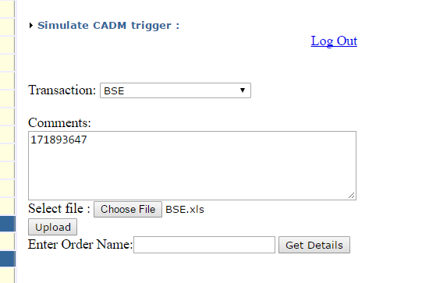

The page should give the following message for successful upload of the sheet.

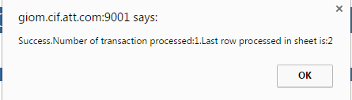

**Step 5**- Now, trigger the billing to CADM.

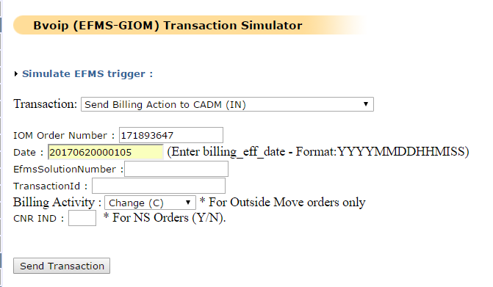

Once triggered, check back the order status in the BVOIP tool, BSE should be success.

**Step 6**- After successful billing transaction, ask EFMS team to skip the GTE for the order.

# Validation:

Order should progress in EFMS.

For this sample order-171893647, it got completed in EFMS



